

Help Desk Ticket

Ticket Number: Ticket #0001 Ticket Category: Hardware

Ticket Information

Name: Bob Smith Department: Support Office

Date and Time: 4/25/2021 12:00 AM Technician: Berny Fred

Description of Problem

Bob Smith email to report on a computer check up before he uses it. He also reported that the computer took a long time to boot up.

Technician Response

Restart the computer

Hours Worked: 20 min

Pictures (Insert Additional as Needed)

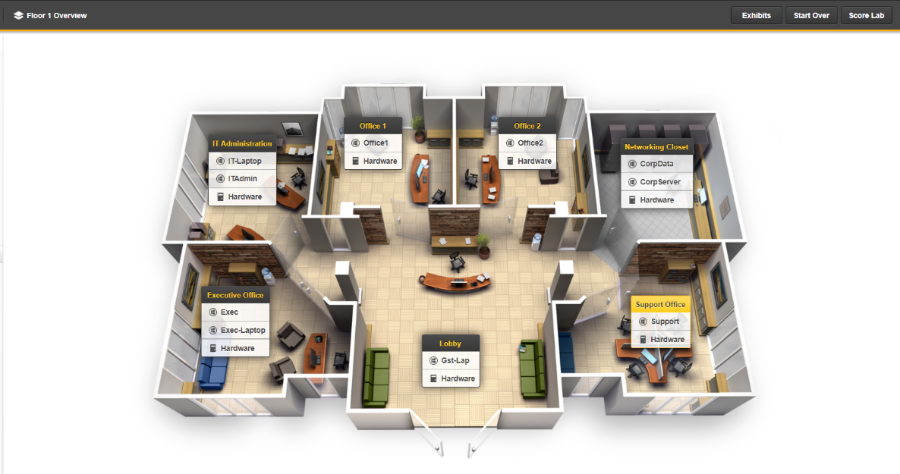

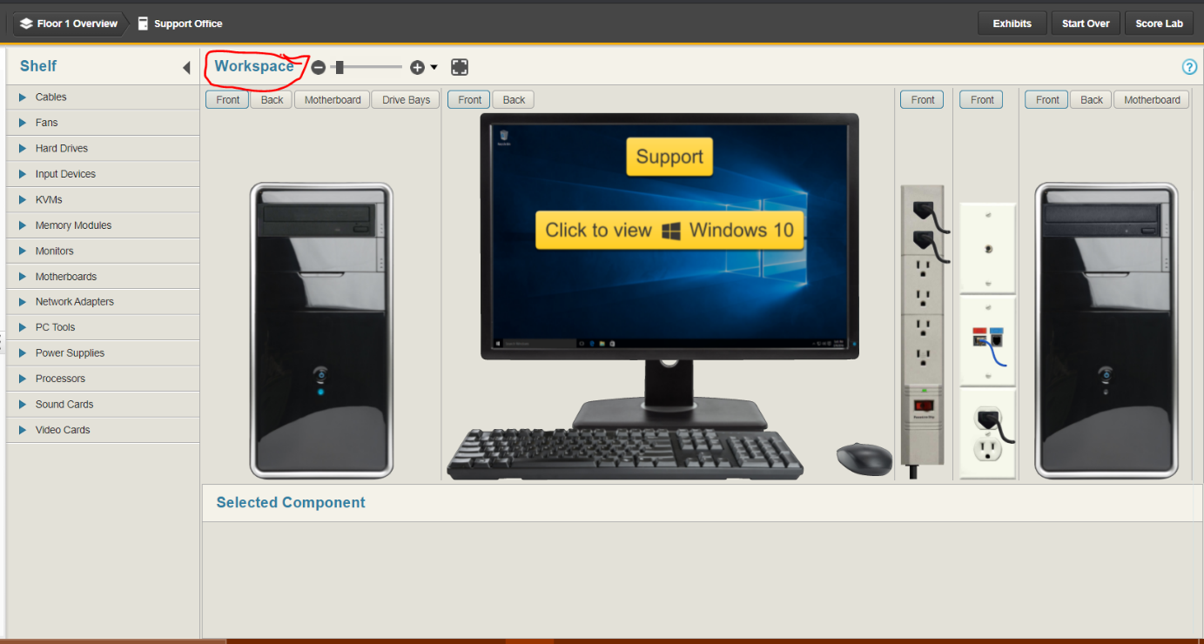

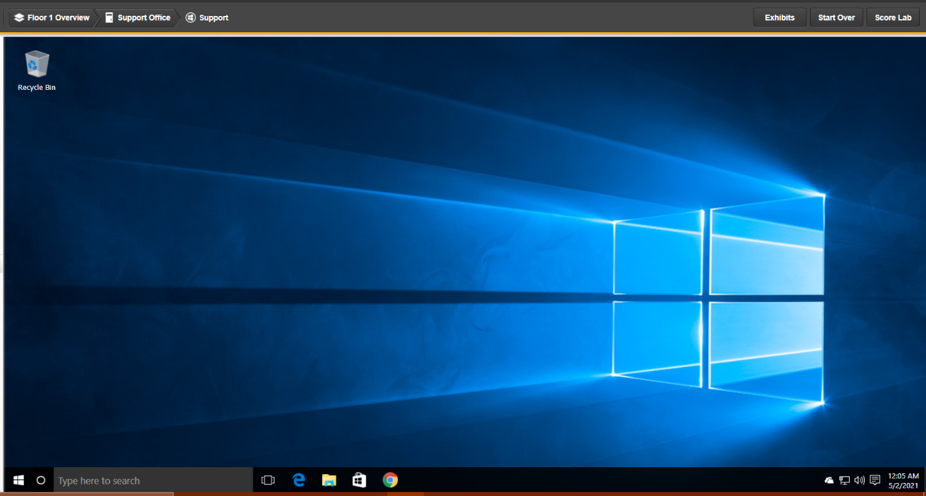

Importance:  Mission Critical  Slowing User Down  Schedule When Able

Conclusion:  Resolved  Pending (Escalated)  Unresolved

Additional Comments

Enter any other comments pertinent to the issue